SIMATS ENGINEERING
SAVEETHA INSTITUTE OF MEDICAL AND TECHNICAL SCIENCES
CHENNAI – 602105
Department of Computer Science and Engineering

ASSESSMENT TOOL 1 – INDUSTRY PROBLEM SOLVING

Course Code: | DSA0502 | Course Title: | Query Processing for Data Science
CO Assessed: | CO5 | Assessment: | Tool 2– INDUSTRY PROBLEM SOLVING
Weightage: | 35% | Total Marks:
CO5 Statement: Create meaningful visualizations using Pandas and Matplotlib, including charts, distributions, relationships, and interactive visual representations for effective communication
Student Name: | G Rajasekhar Reddy | Reg. No.: | 192424216
Section / Batch: | B.Tech-AI&DS | Date of Submission: | 23/08/2026
Faculty In-charge: | Dr. B.Shyamala Gowri | Project Mode: | Individual Submission

Code of Conduct
I G. Rajasekhar Reddy(192424216) (Name / Reg No) certify that this submission is my original work and that I have adhered to all guidelines specified for this assessment. I understand that any violation of academic integrity rules will result in disciplinary action.
Signature: G. Rajasekhar Reddy

- Manufacturing Production Analysis
A manufacturing company records daily production, machine operating hours, temperature, energy consumption, and defect count. Import and explore the dataset using Pandas. Develop visualizations to analyze production trends over time, relationships between machine parameters and defects, and distributions of production values. Use a scatter matrix, lag plot, and autocorrelation plot to identify hidden production patterns and provide recommendations for improving efficiency.
Aim:
To import and analyze manufacturing production data using Pandas and create visualizations using Matplotlib to study production trends, relationships between machine parameters and defects, production distributions, and hidden production patterns.
Program:
import pandas as pd
import matplotlib.pyplot as plt
from pandas.plotting import scatter_matrix, lag_plot, autocorrelation_plot
data = pd.read_csv("manufacturing.csv")
print(data.head())
print(data.describe())

plt.figure(figsize=(8, 5))
plt.plot(data["Date"], data["Production"], marker="o")
plt.xlabel("Date")
plt.ylabel("Production")
plt.title("Production Trend Over Time")
plt.xticks(rotation=45)
plt.tight_layout()
plt.show()

plt.figure(figsize=(8, 5))
plt.scatter(data["Temperature"], data["Defects"])
plt.xlabel("Temperature")
plt.ylabel("Defects")
plt.title("Temperature vs Defects")
plt.show()

plt.figure(figsize=(8, 5))
plt.hist(data["Production"], bins=5)
plt.xlabel("Production")
plt.ylabel("Frequency")
plt.title("Production Distribution")
plt.show()

scatter_matrix(
data[["Production", "MachineHours", "Temperature", "Energy", "Defects"]],
figsize=(10, 10)
)
plt.suptitle("Scatter Matrix of Production Data")
plt.show()

plt.figure(figsize=(8, 5))
lag_plot(data["Production"])
plt.title("Lag Plot of Production")
plt.show()

plt.figure(figsize=(8, 5))
autocorrelation_plot(data["Production"])
plt.title("Autocorrelation Plot of Production")
plt.show()

Output:
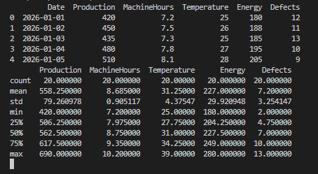

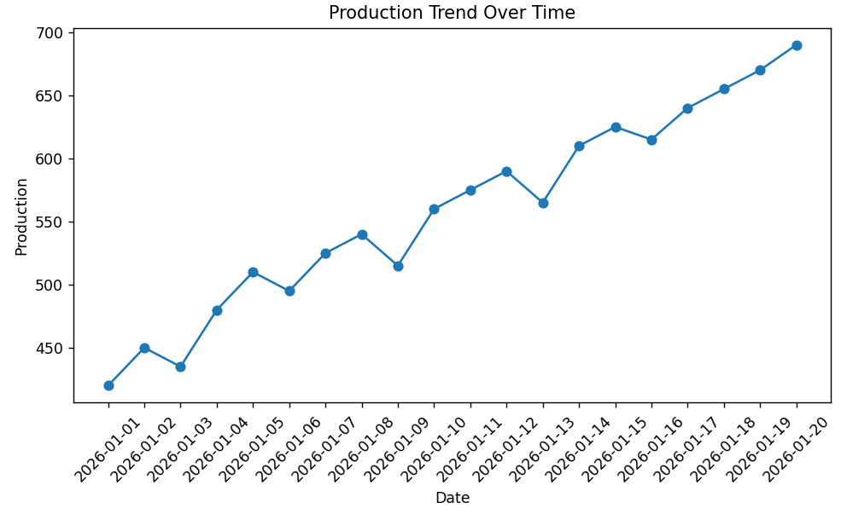
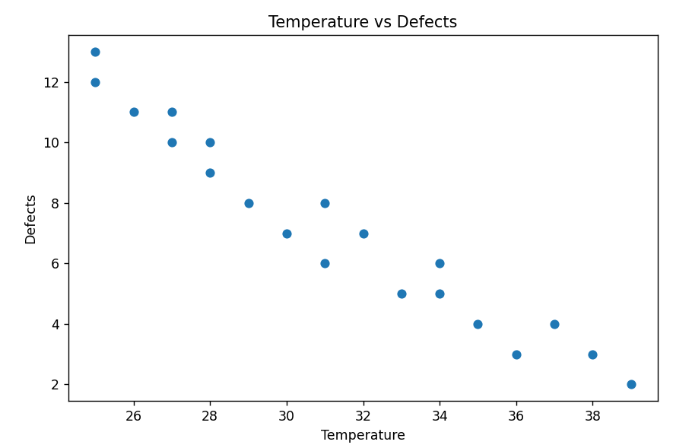

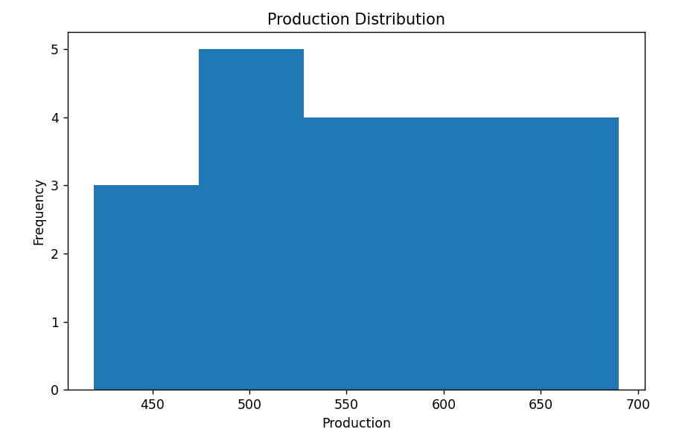

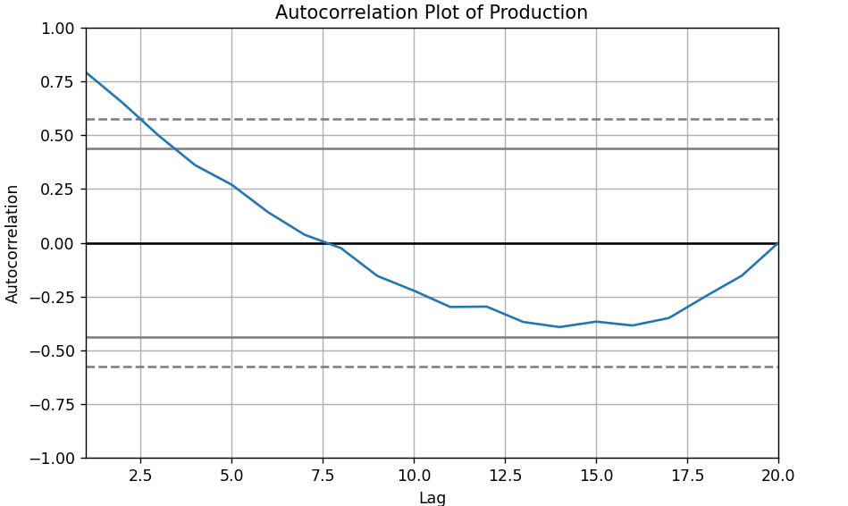
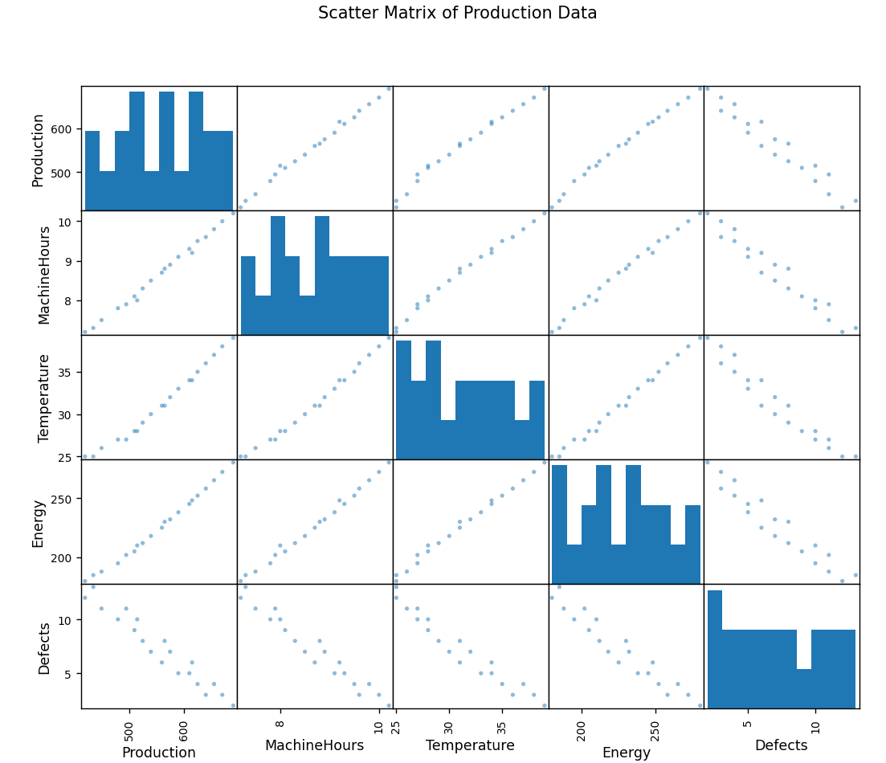

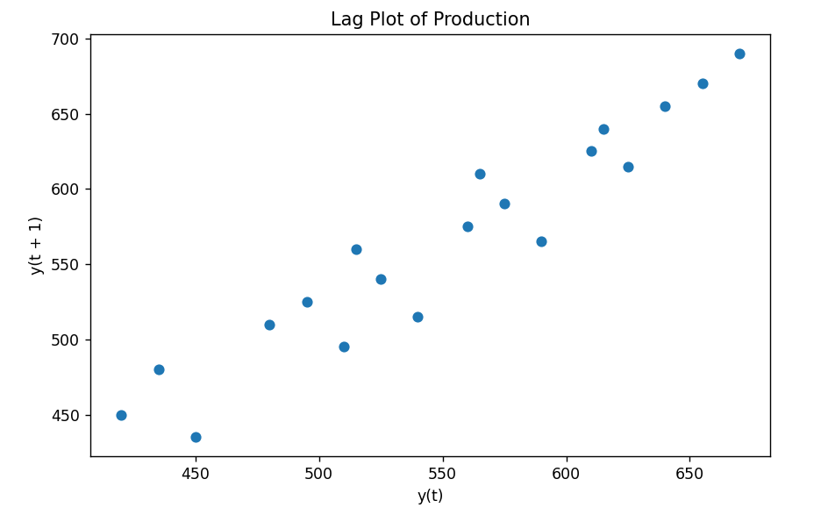

- E-Commerce Sales Pattern Analysis
An e-commerce company has historical data containing date, product category, quantity sold, revenue, discount, and customer rating. Analyze the evolution of sales over time and identify relationships between discount, quantity, and revenue. Use appropriate bar charts, line charts, distribution plots, frequency plots, and scatter matrices to identify important business patterns.

Aim:
To import and analyze e-commerce sales data using Pandas and create visualizations using Matplotlib to study sales trends and relationships between product category, quantity sold, revenue, discount, and customer rating.

Program:

import pandas as pd
import matplotlib.pyplot as plt
from pandas.plotting import scatter_matrix

data = pd.read_csv("ecommerce.csv")

print(data.head())
print(data.describe())

plt.figure(figsize=(8, 5))
plt.plot(data["Date"], data["Revenue"], marker="o")
plt.xlabel("Date")
plt.ylabel("Revenue")
plt.title("Revenue Trend Over Time")
plt.xticks(rotation=45)
plt.tight_layout()
plt.show()

plt.figure(figsize=(8, 5))
data.groupby("Category")["Quantity"].sum().plot(kind="bar")
plt.xlabel("Product Category")
plt.ylabel("Quantity Sold")
plt.title("Quantity Sold by Product Category")
plt.xticks(rotation=45)
plt.tight_layout()
plt.show()

plt.figure(figsize=(8, 5))
plt.scatter(data["Discount"], data["Revenue"])
plt.xlabel("Discount")
plt.ylabel("Revenue")
plt.title("Discount vs Revenue")
plt.show()

plt.figure(figsize=(8, 5))
plt.hist(data["Revenue"], bins=5)
plt.xlabel("Revenue")
plt.ylabel("Frequency")
plt.title("Revenue Distribution")
plt.show()

plt.figure(figsize=(8, 5))
plt.hist(data["Quantity"], bins=5)
plt.xlabel("Quantity Sold")
plt.ylabel("Frequency")
plt.title("Quantity Sold Frequency")
plt.show()
scatter_matrix(
data[["Quantity", "Revenue", "Discount", "Rating"]],
figsize=(10, 10)
)
plt.suptitle("Scatter Matrix of E-Commerce Data")
plt.show()

Output:

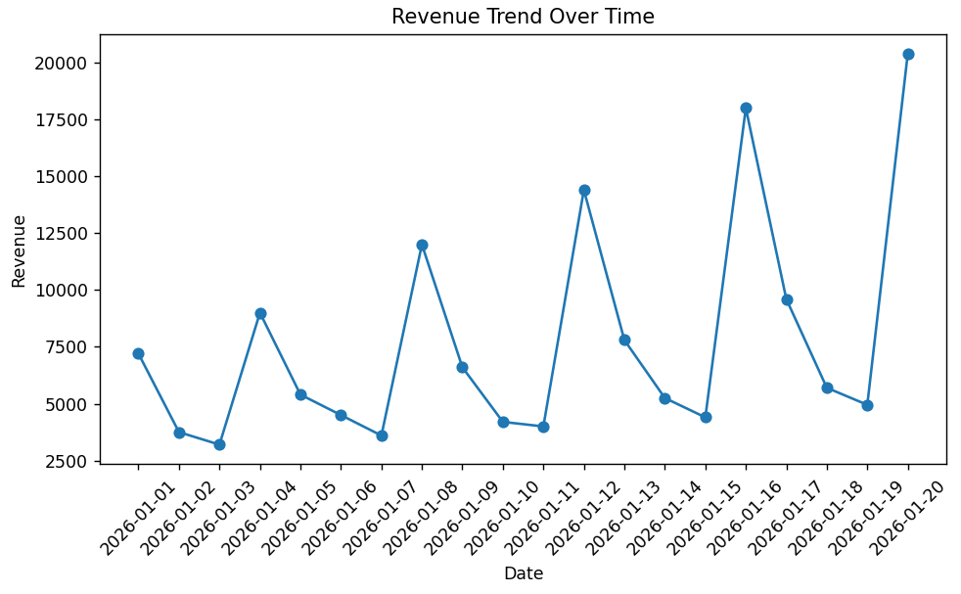

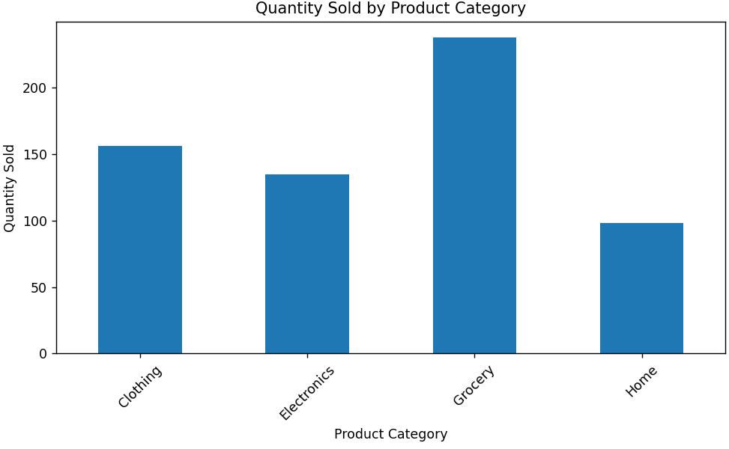
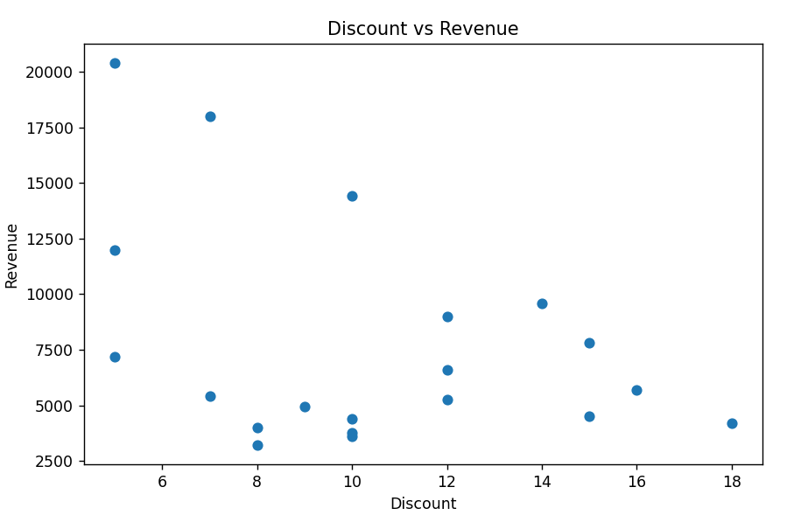

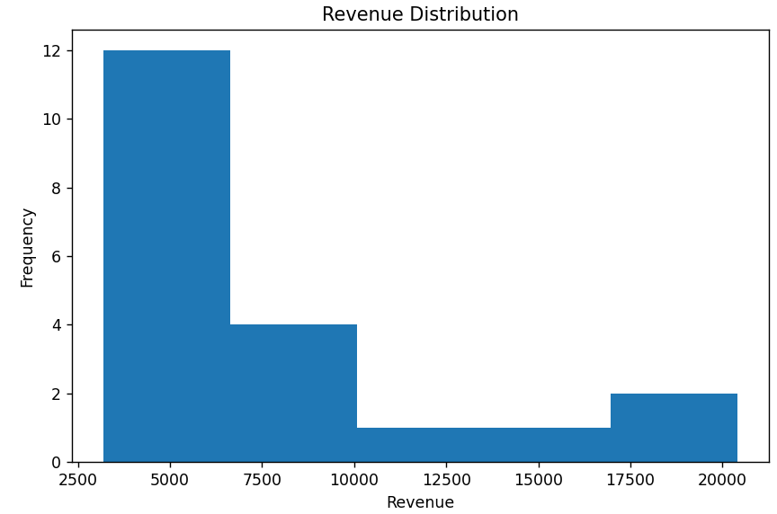

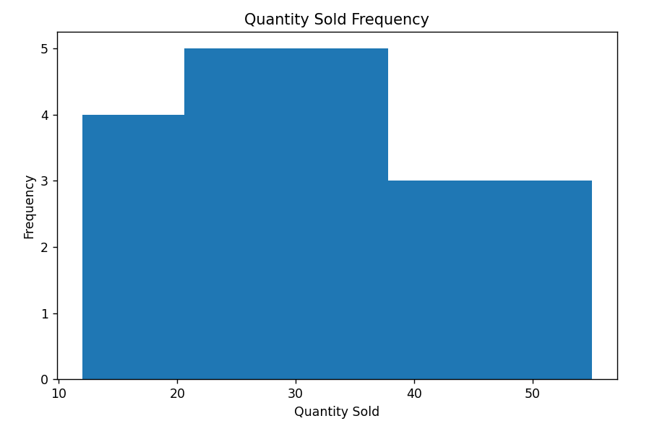
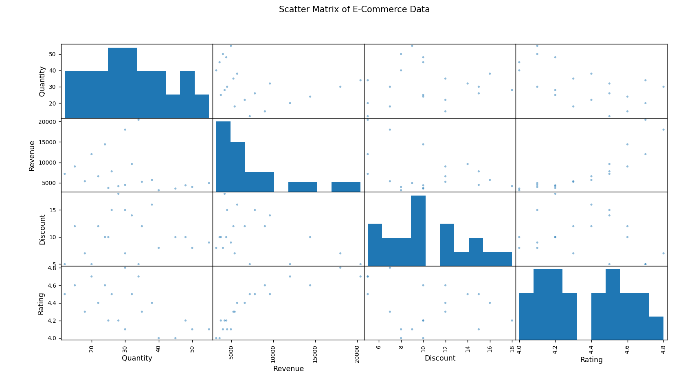

窗体底端

